**Build monitor plugin:**

* It is used to monitor the jobs
* Install build monitor view plugin. After that, we can see the below option while creating new view

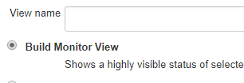

* After this, we can select the jobs whatever we want

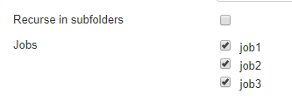

* We can also use order by option

**List view:**

* While we create a list view, we select the columns along with the jobs. Below are the default columns

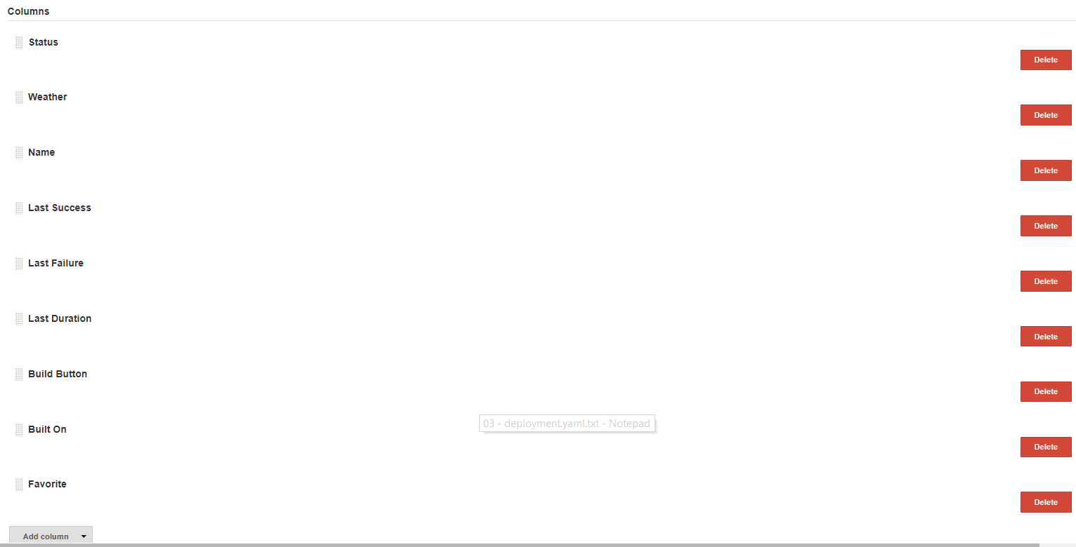

* We can add more columns if we want

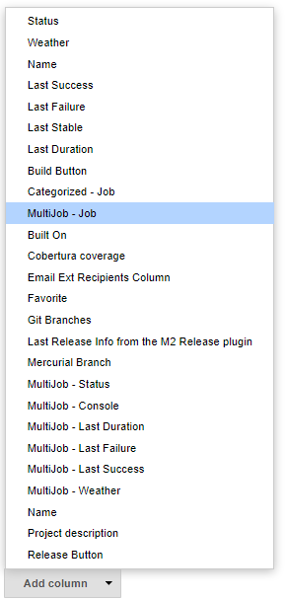

* So, finally the list view will be as below with the colums

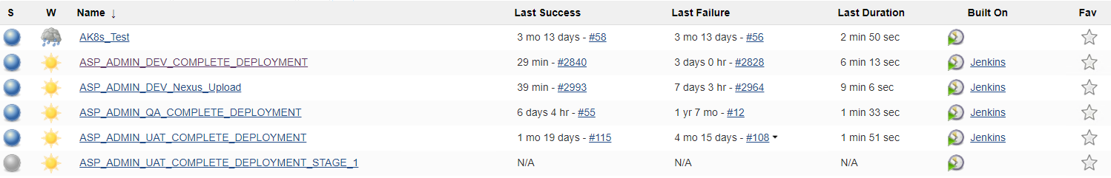

**Build pipeline view:**

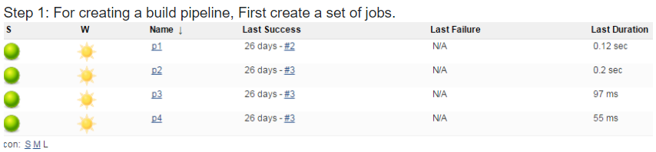

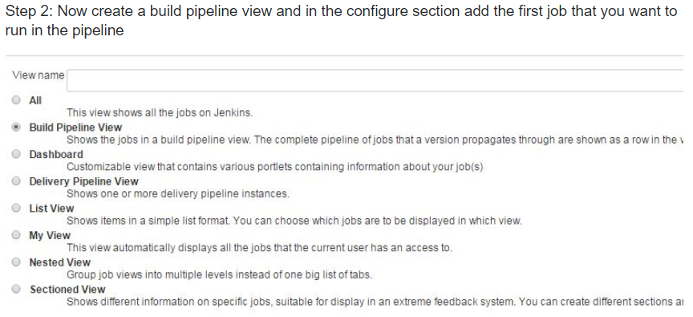

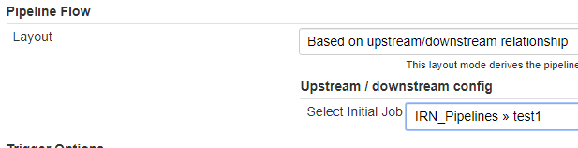

* We need to add the initial job as above. If we are creating a view inside a folder, then the pipeline will be shown as above along with the folder name

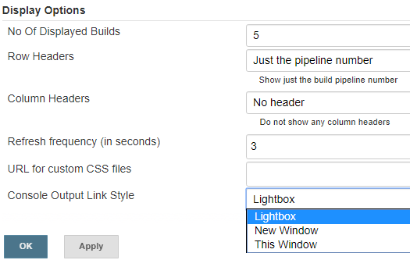

* We can also select the “no of displayed builds” and “console output link style” as above
* Light box, we can see the job console output in small window or we can select to open the console output in a normal same window or in different window

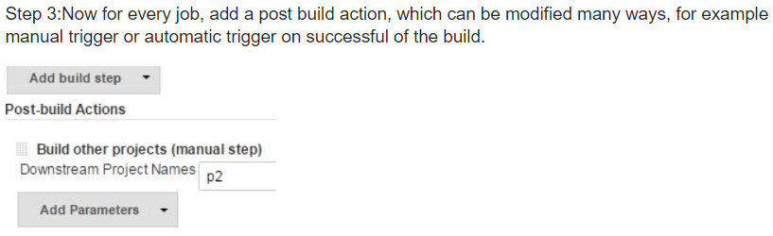

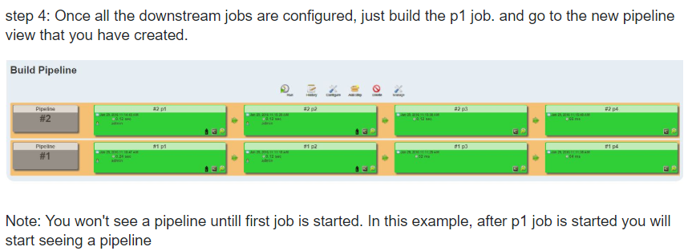

* We can’t see the pipelines in view if the jobs are new and not even executed for once

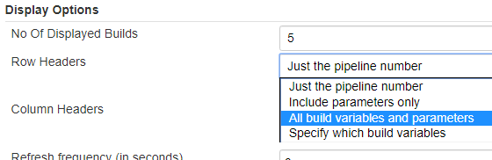

* We can select the “all build variable and parameters” in the view, we can able to see the full details as below

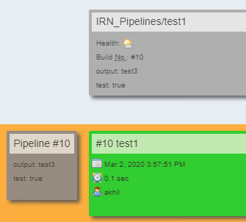

* “row headers” is for the pipeline and “column headers” is to show on top of the view as above